
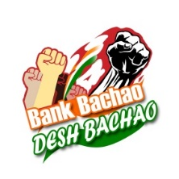
All India Bank Officers’ Confederation
(WEST BENGAL STATE UNIT)
“Samriddhi Bhavan”, E-Block, 6th Floor, 1, Strand Road, Kolkata – 700 001
C/o. State Bank of India Officers’ Association (Bengal Circle)

ALL LETTER TO BE ADDRESSED
TO THE SECRETARY
E-mail: aibocwbsu22@gmail.com
Mobile No.: +91 9434551152

Circular No. 20/2025 Date : 04.04.2025

To All Affiliates (Please Circulate)

We reproduce hereunder the Circular No. 2025/18 dated 04.04.2025 issued by the General Secretary (AIBOC), the contents of which are self-explicit.

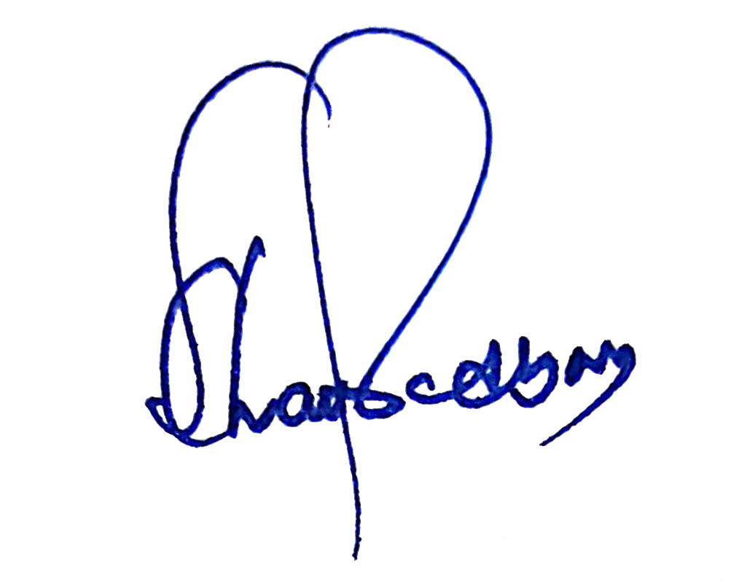
With warm wishes and revolutionary greetings,

(Shubhajyoti Chattopadhyay)
Secretary
AIBOC (West Bengal State Unit)

Dear Comrades,

AIBOC EXTENDS ITS ABSOLUTE SUPPORT IN SOLIDARITY WITH AIUCBOF ON THEIR AGITATION PROGRAMME INCLUDING TWO DAYS STRIKE IN UCO BANK ON 21.04.2025 & 22.04.2025

With reference to the above, we have today sent a communication to the General Secretary, All India UCO Bank Officers’ Federation, extending our full and unflinching support to their struggle including two days’ nationwide strike in UCO Bank on 21st and 22nd April, 2025. Text of the letter is attached herewith for your information. We once again urge all affiliates and state units of AIBOC to extend their solidarity and active presence in their agitational programmes to make it a grand success.
With revolutionary greetings,

Yours Comradely,

Sd/-
Rupam Roy
General Secretary

Text of Letter No. AIBOC/2025/06 dated 04.04.2025

The General Secretary
All India UCO Bank Officers’ Federation

Dear Comrade,

AIBOC EXTENDS ITS ABSOLUTE SUPPORT IN SOLIDARITY WITH AIUCBOF ON THEIR AGITATION PROGRAMME INCLUDING TWO DAYS STRIKE IN UCO BANK ON 21.04.2025 & 22.04.2025

On behalf of the All India Bank Officers’ Confederation (AIBOC), we extend our solidarity and unflinching support to the All India UCO Bank Officers’ Federation (AIUCBOF), an affiliate of AIBOC in their rightful and just cause for the welfare of the officers of UCO Bank.

We are fully aware of the challenges and grievances that have led to the decision to call for a “Two Days’ Strike” on 21st & 22nd April, 2025, as detailed in the strike notice and supported by the Statement of Case and Action Programs. It is regrettable that despite persistent efforts by AIUCBOF through various communications and personal visit to the Top Executives of the Bank including the MD & CEO to address the issues through dialogue and negotiation, the management has not taken the necessary steps to resolve them. The refusal of the management to engage the Federation constructively, leaves no other option but to resort to organisational action.
_______________________________________________________________________________________________
Shubhajyoti Chattopadhyay
Secretary
Mobile : 9434551152
All India Bank Officers’ Confederation
(West Bengal State Unit)

: 2 :

The demands raised by your federation are legitimate and crucial for maintaining a harmonious industrial environment with positive motivation of workforce and ensuring the continued growth and success of the Bank. Issues such as utilisation of bipartite forums to take any decision regarding review and framing of transfer policy, improvement in the service conditions of officers and introduce fair HR practices are essential for the well-being of the workforce and the Bank’s operational efficiency.

AIBOC stands firmly with AIUCBOF in their pursuit of justice and fairness. We recognize the significance of the proposed action programs, including the strike on 21st & 22nd April, 2025 and acknowledge the necessity of these steps to bring attention to the unresolved issues affecting the entire officers’ community of UCO Bank.

We, through this communication, call upon the management of UCO Bank also to take immediate and sincere steps to resolve the demands raised by AIUCBOF to prevent further disruption and unrest within the Bank. We also urge all affiliates and state units of AIBOC to extend full support to our comrades in AIUCBOF and join their struggle enmasse.

Together, we stand united in solidarity for justice, fair treatment, and the rights of all employees and officers.

With revolutionary greetings,

Sd/-
(Rupam Roy)
General Secretary

_______________________________________________________________________________________________
Shubhajyoti Chattopadhyay
Secretary
Mobile : 9434551152

